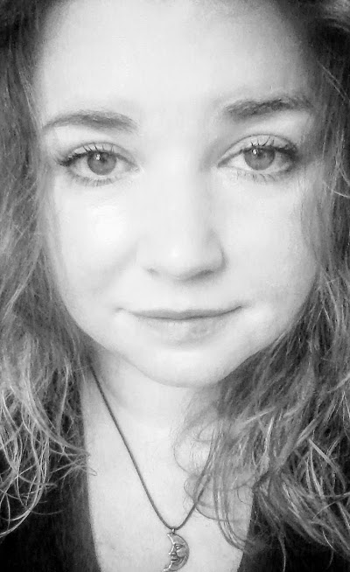  I’ve always loved making, watching, and producing art. I am a hard worker. Passionate about my art. I will create and envision your idea and make it come to life. I have experience, practice and knowledge in traditional media and digital painting. If you’re an author, I will work with you to bring your ideas to life, with beautiful, eye-catching illustrations. I paint portraits also. If you want a mural done, or your own idea specialized just for you, please contact me! I’d love to work for you!  CONTACT  PHONE:  336-858-9351  WEBSITE:  www.jessicawrike.wordpress.com  www.othersideoftheprism.weebly.com  EMAIL:  Jwrike86@gmail.com  HOBBIES  Reading/ listening to audiobooks  Crocheting  Sewing |  | Jessica Wrike  Freelance Illustrator/Artist  Children’s Book Illustrator & Author  Education  Art Institute of Pittsburgh (Online Division)  April 2014 – August 2017  Certificate in 2D Animation  Major: 2D Animation  GPA: 3.07  Awarded the Academic Achievement Grant by AIO.  Over $1,000 to help with my tuition.  Featured in an article titled, “2D Animation Grad Featured by Barnes and Noble as Local Artist,” by The Art Institute of Pittsburgh.  Website link:  aiostudent-life.com  WORK EXPERIENCE  Self-Published “A Collection of My Most Recent Works”  (October 2019)  Created Cover and interior  Set up book design  Collaborated with Author on “ The Greener Pond” Children’s Book  (May-August 2019)  Illustrated authors ideas  Designed front and back covers  Responsible for book design  Self published book for author  The Purrfect Place (Non-Profit Rescue Organization)/ Volunteer  (October 2018-Present)  Set up website  Created Facebook Page  Set up PayPal  Linked PayPal to website and Facebook page  Sent in necessary paperwork  Post, promote, advertise and keep up with Facebook page  Volunteer at Events  Self-Published/ Author and Illustrator  Published Fourth Book (January 16, 2019)  The Purrfect Place Coloring Book  Created the cover of the book, except for the logos.  Placed logos, sized images for cover and interior,  Fixed for trim size & edited in Photoshop.  Illustrated the interior pages of the book.  Available @ Amazon.com  Self-Published/Author and Illustrator  Published My Third Book (December 7, 2018)  The Growing Ups of Aurora Josephine  Created a story and illustrated a personalized book  for a client.  Available @ Amazon.com, and Sunrise Books in High Point, NC  Freelance Artist  Portrait Work (October 2018)  Titled: Bliss  Painted a black and white portrait of my client’s sister’s son.  Materials: black, grey and white acrylic paint/  Various brushes and art tools  Self-Published/Author and Illustrator  Published My First Children’s Book (February 2018)  My Colorful Alphabet Book  Sketched first in pencil, went over in pen and markers.  Cleaned up in Photoshop.  Materials: Copic, Tombrow and Faber-Castell markers, Micron and Copic markers  Available @ Amazon.com, and Sunrise Books in High Point, NC  Self-Published/Illustrator  Published an Adult Coloring Book (July 2017)  A Dreamer’s Wonderland  Added color to cover using Adobe Photoshop.  Hand drawn, using Micron and Copic illustration pens.  Available @ Amazon.com, and Sunrise Books in High Point, NC  Volunteer work (2016)  Designed, sewed about 40 bears for UNC Chapel Hill’s  Children’s Hospital  Designed, sewed fidget blanket for a friend with  traumatic brain injury  Design Work (2014 -2016)  Special orders: designed, sewed pillows, blankets  SKILLS

